Algebra 1: Unit 3, Lesson 7

- A scatter plot, line of best fit and a regression analysis is shown for a linear equation fit to model the data.
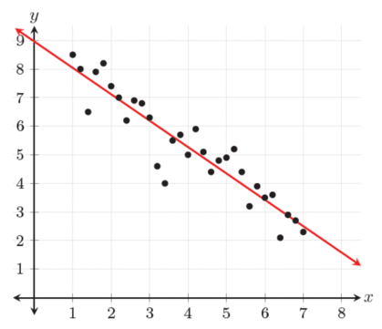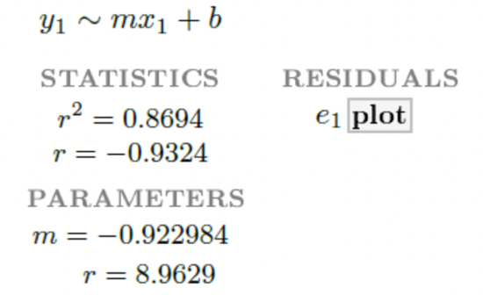
$$y=-0.922984x+8.9629$$
What is the equation for the line of best fit?

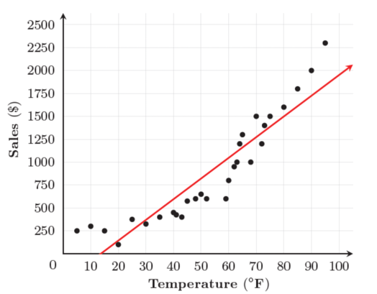
- Caleb, the owner of a pontoon boat rental, wondered if there was a trend between the outside temperature, in degrees Fahrenheit (∘F), and sales from pontoon rentals, in dollars. Caleb used the data he collected to create the scatter plot shown.
Complete the statements.
The slope of the line of fit is _________________. This means that as the outside temperature _____________ sales from pontoon boat rentals _____________.
Positive, increases, increase

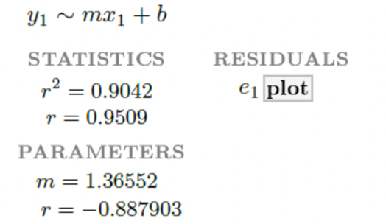
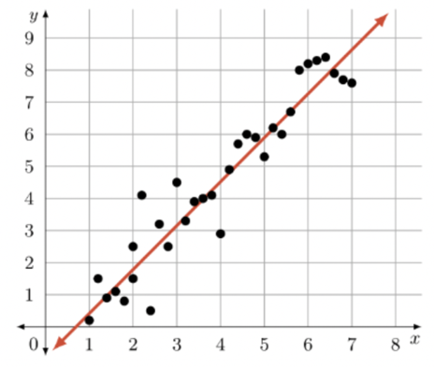
- A scatter plot, line of best fit and a regression analysis is shown for a linear equation fit to model the data.

$$0.9509$$
What is the correlation coefficient?

